1. Downloaded Data
2. Store raw data into hdfs location

ls /tmp/hive_classes -l -> On Local Path

hdfs dfs -ls /tmp/hive_classes -> HDFS Location

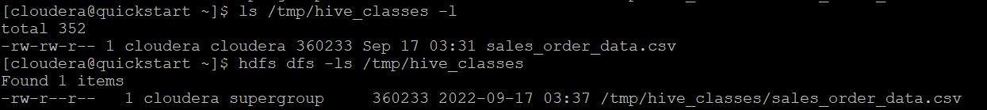

1. Create a internal hive table "sales_order_csv" which will store csv data sales_order_csv .. make sure to skip header row while creating table

create table sales_order_csv(ORDERNUMBER int, QUANTITYORDERED int, PRICEEACH float, ORDERLINENUMBER int,SALES float, STATUS string, QTR_ID int, MONTH_ID int, YEAR_ID int, PRODUCTCODE int, MSRP string, PHONE int, CITY string, STATE string, POSTALCODE int, COUNTRY string, TERRITORY string, CONTACTLASTNAME string, CONTACTFIRSTNAME string, DEALSIZE string) row format delimited fields terminated by ',' lines terminated by '\n' tblproperties ("skip.header.line.count"="1");

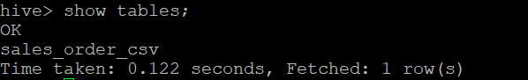

1. Load data from hdfs path into "sales_order_csv"

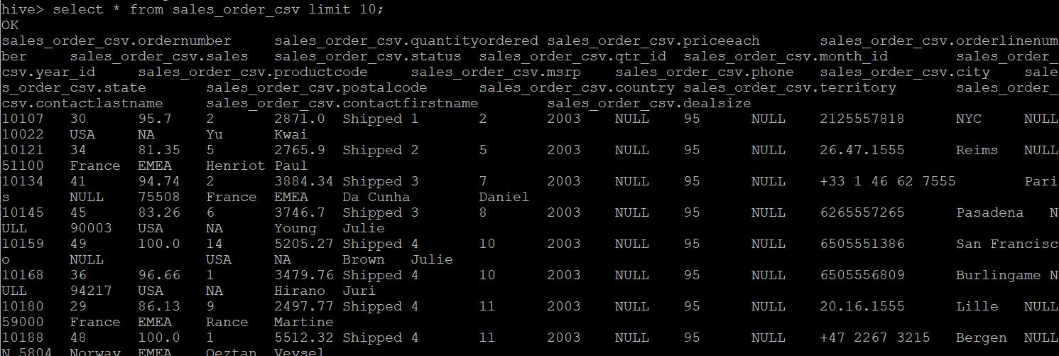

load data inpath '/tmp/hive_classes1/sales_order_data.csv' into table sales_order_csv;

set hive.cli.print.header = true;

select * from sales_order_csv limit 10;

1. Create an internal hive table which will store data in ORC format "sales_order_orc"

create table sales_order_csv(ORDERNUMBER int, QUANTITYORDERED int, PRICEEACH float, ORDERLINENUMBER int,SALES float, STATUS string, QTR_ID int, MONTH_ID int, YEAR_ID int, PRODUCTCODE int, MSRP string, PHONE int, CITY string, STATE string, POSTALCODE int, COUNTRY string, TERRITORY string, CONTACTLASTNAME string, CONTACTFIRSTNAME string, DEALSIZE string) stored as orc;

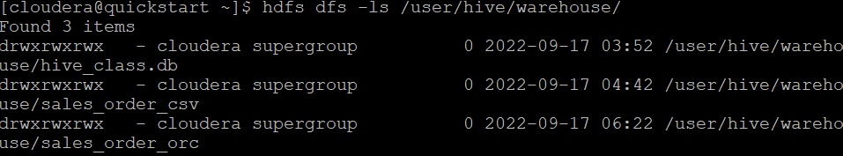

1. Load data from "sales_order_csv" into "sales_order_orc"

from sales_order_csv insert overwrite table sales_order_orc select *;

set hive.cli.print.header=true;

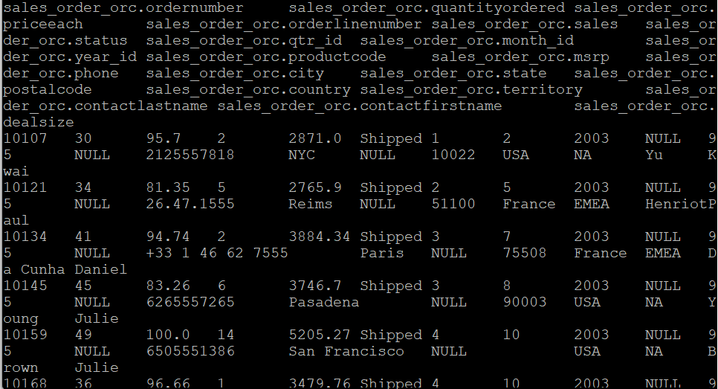

1. Calculatye total sales per year

select YEAR_ID as Year, sum(SALES) as Sales from sales_order_csv group by YEAR_ID;

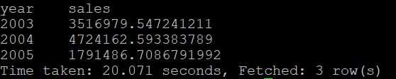

1. Find a product for which maximum orders were placed

select productline, sum(ORDERLINENUMBER) as orders from sales_order_orc group by productline order by orders desc;

or

select a.* from(select productline, sum(ORDERLINENUMBER) as orders, dense_rank() over(order by sum(orderlinenumber) desc) as rank from sales_order_orc group by productline) a where rank=1;



1. Calculate the total sales for each quarter

select QTR_ID as quarter, sum(sales) as sales from sales_order_orc group by QTR_ID order by sales desc;

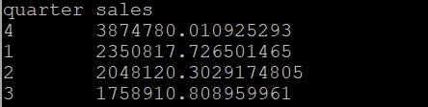

1. In which quarter sales was minimum

select a.* from(select QTR_ID as quarter, sum(sales) as sales, dense_rank() over(order by sum(sales) asc) as rank from sales_order_orc group by QTR_ID) a where a.rank=1;

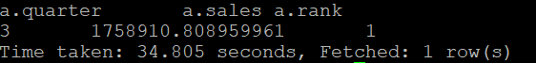

1. In which country sales was maximum and in which country sales was minimum

select b.country as country, b.sales as sales from(select a.country as country, a.sales as sales from(select country, sum(sales) as sales, dense_rank() over(order by sum(sales) asc) as rank from sales_order_orc group by country) a where a.rank=1 union all select a.country as country,a.sales as sales from(select country, sum(sales) as sales, dense_rank() over(order by sum(sales) desc) as rank from sales_order_orc group by country) a where a.rank=1) b order by sales desc;

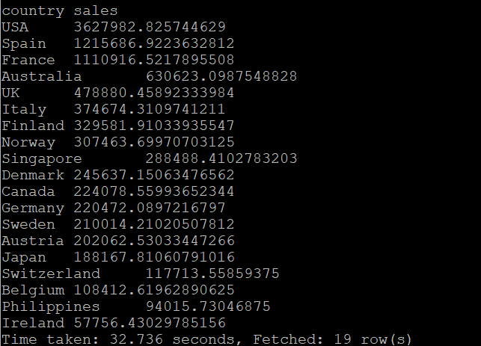

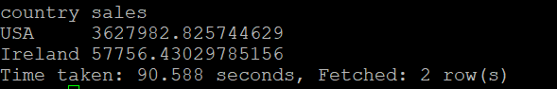

1. Calculate quartelry sales for each city

select city,qtr_id as quarter, sum(sales) as sales from sales_order_orc group by city,qtr_id;

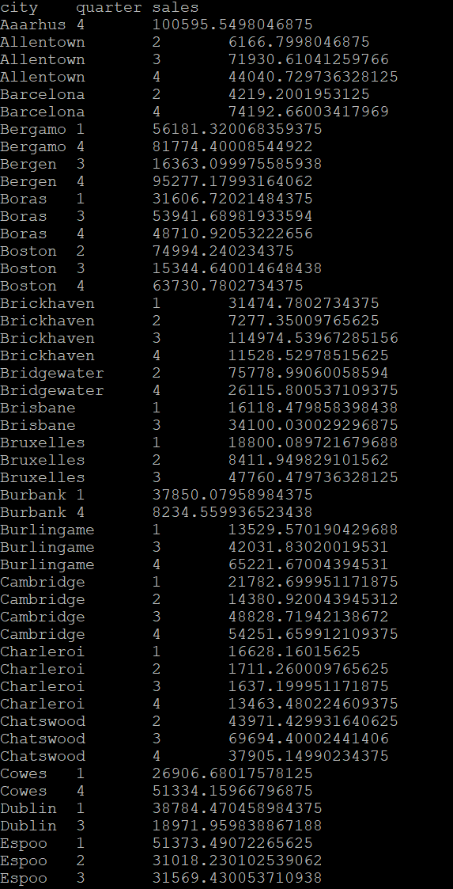

1. Find a month for each year in which maximum number of quantities were sold

select a.year_number as year, a.month_number as month, a.quantities_sold as quantities_sold from(select year_id as year_number, month_id as month_number,sum(QUANTITYORDERED) as quantities_sold, dense_rank() over(partition by year_id order by sum(QUANTITYORDERED) desc) as rank from sales_order_orc group by year_id, month_id) a where a.rank=1;

